2026
Website Proposal 2

Paws and hearts animal shelter
Tiisetso Diketso Tsaka Lerato Chipa
Contents
Proposal 2: Paws & Hearts Animal Shelter (Non-Profit) 2
1. Organisation Overview 2
2. Website Goals and Objectives 2
3. Current Website Analysis 2
4. Proposed Website Features and Functionality 3
5. Design and User Experience 3
5.1 Wireframe Webpage Design 4
5.2 Site Map Design 5
6. Technical Requirements 5
7. Timeline and Milestones 5
8. Budget 6
9. Gift Hub 6
10. References 6

Proposal 2: Paws & Hearts Animal Shelter (Non-Profit)

1. Organisation Overview
- Name: Paws & Hearts Animal Shelter
- History: Paws & Hearts Animal Shelter is a hypothetical non-profit organisation, imagined as having originally been made by a small group of volunteers to rescue, rehabilitate stray and abandoned animals in the local community.
- Mission and vision: To rescue and care for vulnerable animals, find them loving permanent homes, and reduce the number of stray animals.
- Target audience: Pet adopters, donors, and animal-welfare volunteers, and people wanting to report strays or get involved.

2. Website Goals and Objectives
- Goals: Increase local adoption, grow the volunteer base, and raise awareness and donations to fund the shelters day-to-day.
- Key performance indicators (KPIs): Number of adoption enquiry submissions, volunteer sign-ups, and clicks on the donate call-to-action.

3. Current Website Analysis
- Current online presence: Paws & Hearts Animal Shelter has no dedicated website. Its only online presence is a shared community social media page that is used by local animal-welfare volunteers, not the shelter alone.
- Strengths of the current presence: the page reaches caring people when adoption posts are shared, and it costs nothing to maintain. Photos of animals needing homes do create some engagement and comments from the community.
- Weaknesses of the current presence: because the page is shared with other volunteers and causes, Paws & Hearts' own posts about adoptable animals, donation drives, and volunteer opportunities are frequently buried and hard for new visitors to find. There is no single, reliable place to see current adoptable animals, submit a volunteer, find shelter opening hours, or find the local clinic. Donors and adopters who search online for the shelter by name have no dedicated page to land on. There is also no consistent branding, so visitors deciding whether to trust it with a donation.
- Areas for improvement identified: a dedicated website that clearly separates Paws & Hearts from other causes; a simple, browsable list of animals available for adoption; a single enquiry form covering adoption, volunteering, and sponsorship; clear contact details and directions for both the main shelter and clinic.

4. Proposed Website Features and Functionality
- Homepage: hero image, brief introduction, call to action to adopt/donate/volunteer
- About Us: shelter history, mission and the volunteer team
- Services: animals available for adoption and services offered (rescue, sterilisation drives)
- Enquiry: form for adopting, volunteering, or becoming a sponsor
- Contact: details and a map for both the main shelter and the satellite clinic

5. Design and User Experience
- Colour scheme: Warm, friendly palette of soft orange and teal on a white background, chosen to feel approachable rather than clinical.
- Typography: A rounded, friendly sans-serif (e.g. Nunito) for headings, paired with a highly readable sans-serif for body copy.
- Layout and design approach: Layout that puts animal photos front and centre, with a simple top navigation bar across all pages.
- User experience considerations: Clear, minimal navigation, prominent adopt/donate/volunteer buttons on every page, and mobile-responsive design so visitors browsing on phones can adopt or donate easily.
- High-fidelity wireframe (page structure, top to bottom): Header with logo and navigation, full-width hero image with call to action, animal highlight cards, impact statistics strip, footer with contact details and social links.

5.1 Wireframe Webpage Design
Figma Link: https://www.figma.com/design/u7l0PcOV4E4UIqjXXmU6sH/Untitled?node-id=0-1&t=ogalzznYEDa5cDo4-1

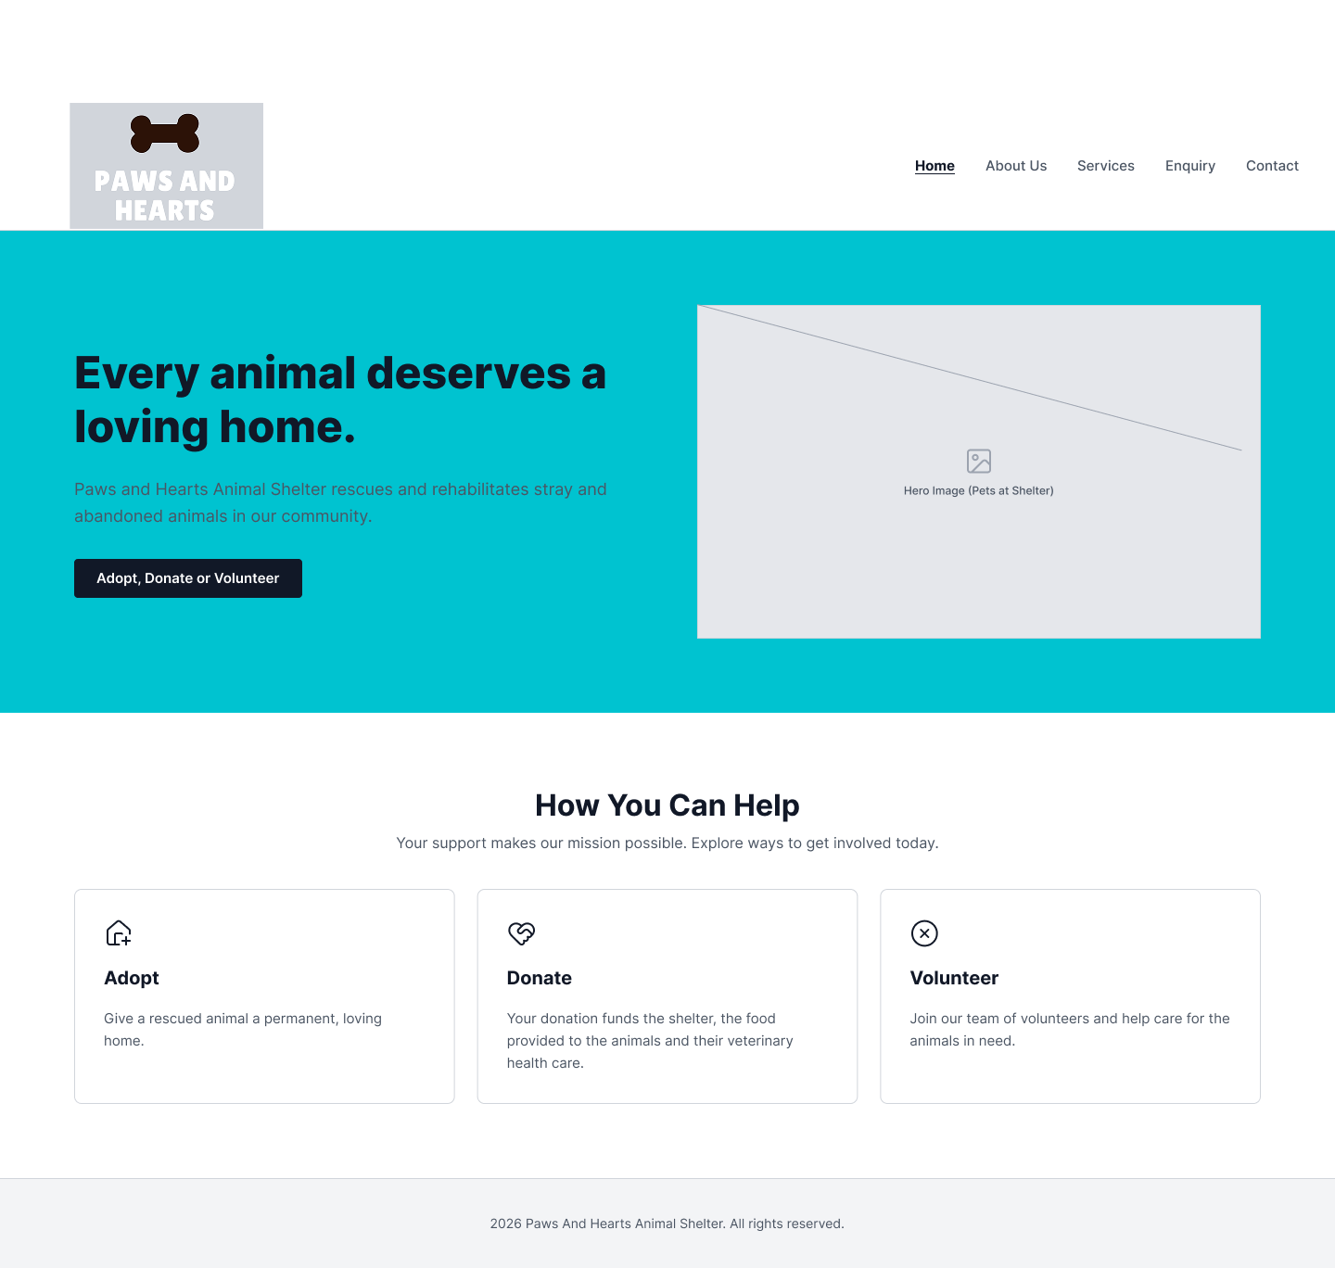
Figure 1: Home

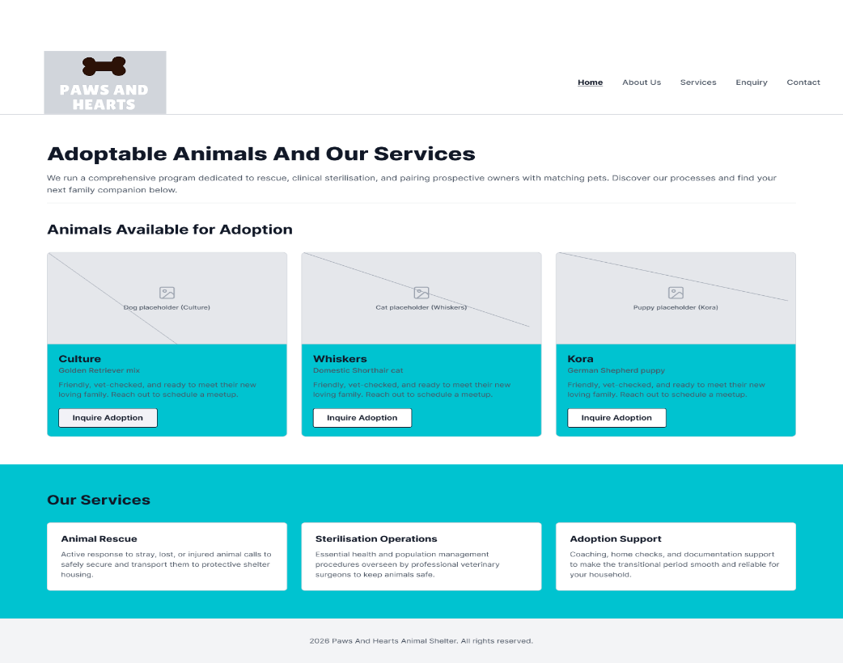

Figure 2: Services page

5.2 Site Map Design
Site Map Design Link: https://www.figma.com/design/u7l0PcOV4E4UIqjXXmU6sH/Untitled?node-id=7-2&t=ogalzznYEDa5cDo4-1
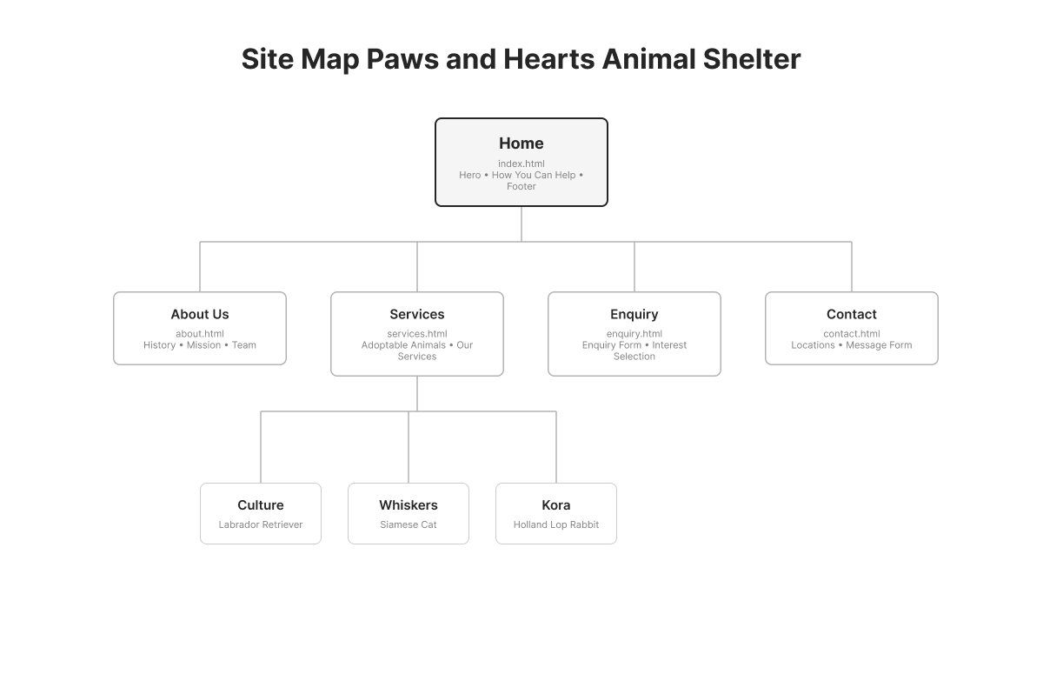
Figure 3:Site Map

6. Technical Requirements
- Hosting and domain: Free or discounted non-profit web hosting with a .org.za domain such as pawsandhearts.org.za.
- Languages and frameworks: HTML5, CSS3, JavaScript (vanilla)

7. Timeline and Milestones
- Part 1 (Weeks 1-4): Planning, research and HTML structure
- Part 2 (Weeks 5-8): CSS styling and responsive design
- Part 3 (Weeks 9-12): JavaScript functionality, SEO and forms

8. Budget
- Domain registration: approximately R150 per year.
- Hosting: free a discounted non-profit plan (approximately R0-R60 per month). The site is built and maintained by volunteers, so development time is not costed.

9. Gift Hub
Gift Hub Repo Link: https://github.com/EMGPPT/wede5020-2026-poe-tiise-glitch/tree/main

10. References
- Mark.W. 2026. Nonprofit organizations: How they work and what they do. [blog]
Available at: < https://www.boardeffect.com/blog/governs-nonprofit-organizations/ > [Accessed 4 August 2026].
- Shelter Animals Count 2026. Understanding Animal Welfare Organizations: Types of Shelters, Rescues, and Services [blog]
Available at: < https://www.shelteranimalscount.org/understanding-animal-welfare-organizations >
[Accessed 4 August 2026].

